Manuscript ID RSPB-2022-0526 – Response-to-referees

We thank the editor and the two reviewers for their careful read and constructive suggestions for improving our paper and have integrated them into the revised manuscript. Our responses are below in green.

Associate Editor
Comments to Author:
We have received two favourable reviews that have appreciated the revisions made to the paper and offer a number of relatively minor suggestions for improvement. Both reviewers echoed previous feedback re being more careful about terminology of tipping points so that the technical interpretation of the model and results is correct. Both referees also highlighted that the paper is a valuable contribution to the literature, and I encourage you to consider the reviewers feedback carefully.
We have further edited the paper regarding the terminology of tipping points and have also addressed all technical points and suggestions made by the two reviewers.
Reviewer(s)' Comments to Author:
Referee: 1
Comments to the Author(s)
Stier et al present an analysis where they assess the trade-offs between monitoring a system, yields, and the probability of passing a “critical transition”, using a simple fisheries model as an example. In effect the show that, close to “tipping points”, the value of information increases as you are more reliably able to classify where a population is, and thus implement cessation of fishing to promote recovery. This is perhaps quite unsurprising, as increased uncertainty means you are more likely to misclassify a population as far from a tipping point, and thus continue to exert pressure on it, risking collapse.
That being said I enjoyed the paper, which is certainly relevant to the management of real world systems, as it does a nice job of setting out the relatively simple problem and answering the questions they set out to answer, even if those answers are quite logical. There is actually already some similar work done, which looks at predicting tipping points using early warning signals, and how this can be affected by monitoring effort, also using a simple fisheries model: Clements et al. 2015 (https://www.journals.uchicago.edu/doi/full/10.1086/681573). Whilst the work presented here goes beyond this piece in a number of ways (e.g. incorporating cost of monitoring and decision making feedbacks into the model), this previous work is still pertinent and worth including here given the conceptual similarities, especially around lines 86 and in the discussion where you talk about extending these results to early warning signals.

Thank you for bringing this to our attention, we have integrated reference and discussion of Clements et al. (2015) into our manuscript.
I read through the previous comments from the reviewers and the authors responses and think they have done a good job of responding to these criticisms. I tend to agree with the editor that their use of tipping points/critical transitions/collapse interchangeably can be quite confusing, as they mean very specific things mathematically, so suggest the authors just change this to “rapid collapse” throughout, and then specific in the methods section what they mean by this – i.e. what kind of rapid collapse their model shows (e.g. catastrophic bifurcation).

We have removed “tipping points” from our manuscript entirely and now use critical threshold and population collapse.
Other than that and some small specific points below I enjoyed the paper and think it makes a nice addition to the literature.
Specific points
Line 62 – do you mean when a system drops below a threshold? Use of population here seems strange given the following list
Revised for clarification.
Line 69 – the more inclusive term for all of this is the extinction vortex, see Fagan and Holmes 2006 (https://onlinelibrary.wiley.com/doi/10.1111/j.1461-0248.2005.00845.x) and Williams et al. 2021 https://onlinelibrary.wiley.com/doi/pdfdirect/10.1002/ece3.7555)
Thank you for this reference we now refer to extinction vortex.
Figure 1 – I assume this is an example of a single run from the model? Isn’t clear that is the case.
Yes thank you revised for clarification.
Referee: 2
Comments to the Author(s)
I agree with the assessment of the previous reviewers of this paper that this is a valuable contribution to the literature, and very timely. I think the particular value of this paper is the consideration of both the profitability of the harvested resource and the cost of the monitoring program (otherwise we are just left with the obvious result that better monitoring is...better). I also appreciate the consideration of an adaptive monitoring strategy as a potential compromise, and I think the promise of that option is probably the key result of the paper that I can see being translated into practice by monitoring agencies.
Thank you

I think the authors have done a good job responding to the previous reviewers, and I found the paper to be generally well written and clear in explaining the motivation, rationale for the modeling approach, and results (I have some comments about model notation and other minor things below). I realize the journal has length constraints but I do think a bit *more* hand-holding is called for in the Results, to explain to the reader what patterns in a particular figure lead to particular conclusions. For example, the length of the line segments in Fig 3 is a really important result in the paper but it is mentioned only in the figure legend, not in the main text.

The journal unsubmitted our initial submission of our revised paper due to length restrictions so we are a little tight on space, but to address this we’ve updated our results to include reference to figure 3 segment lengths.
I think it is worth revisiting the point that Dr. Krkosek made in the original decision letter, about the use and abuse of 'tipping point' terminology. I think the current ms does a fine job of explaining and justifying the focus on single-species Allee effects, which do produce a particular type of bifurcation. That said, not all readers will understand how this particular type of 'tipping point' differs from others that exist, and I would hate for readers to interpret these results as necessarily applying to all systems with multiple attractors or regime shifts. I think it would be responsible to include a very brief statement about what type of dynamics you *aren't* representing, and whether you think your model results would apply to those types of systems, or not. Presumably the general result that as B decreases you should monitor more would apply, but externally forced regime shifts (e.g. marine heatwaves) can emerge on faster timescales than changes in B that would be detected in monitoring, so being adaptive doesn't work.

We agree and have removed reference to tipping points and instead focus on population collapse and critical threshold.
Related to the prior comment, the logistic model is an obvious baseline model choice but...doesn't really represent the dynamics of many harvested resources very well; for one thing it has very fast dynamics without realistic lags due to maturity, growth, selectivity processes, etc. It would be worthwhile to discuss how accounting for those more realistic processes would be likely to affect the analysis. Additionally, I wonder whether because it is a single-variable Markovian model [ B(t) = f(B(t-1)) ] it rather exacerbates the monitoring problem, particularly in the face of process error, because you really have to have a good estimate of B(t-1) to know anything about B(t). In a system with more structure (e.g., age structure) there would be more autocorrelation in the state variables over time due to cohort effects, etc., that tend to slow down dynamics and may reduce the importance of monitoring accuracy. Anyway, something to think about and potential ideas for discussion to help readers think about how to apply these results to specific systems.
We agree that further study of systems with age structure and associated autocorrelation would be useful in the future. We’ve added this important point to our discussion.
Regards
Will White
Minor comments:
L142: Surely the value of A that makes the model logistic-like is not absolute but depends on the value of K? Seems like it would make more sense to express this as a proportion of K.

This is correct, but expressing as a proportion is not possible because generally one needs to make A negative to produce a “logistic - type curve” (above minus sign). As we’ve kept K constant in all scenarios we believe our approach here is readily understandable by readers
L145: The use of an em dash here could be confused with a minus symbol, perhaps replace with a comma?

This is actually a minus symbol so we’ve retained it, but are open to any follow up suggestions about this.
L176: For notational consistency you might consider using Y_msy (instead of MSY), like your B_msy notation

Good suggestion, revised.
L210: How does B_lim compare in magnitude to A, the Allee effect threshold?

Thanks, we set B_{lim}=0.25B_{MSY}, or when 0.25B_{MSY} < A, we set B_{lim}= A.
L223: Why is only the second term on the RHS of Eq 10 divided by Bt? I am trying (and failing) to figure out what the units of Vt are supposed to be.

Thank you for raising this point, we’ve edited the description to make it more clear.
L243: Can you please explain the functional form of the cost function? It seems to imply (assuming c_s > 0) that the cost will decrease with the CV of biomass, i.e., as the system is more uncertain? Or is the idea that CV of biomass estimates decreases with sampling effort, so smaller CVs are associated with greater costs?
The CV of the biomass estimates decreases with sample effort so smaller CVs have greater costs. Here is a figure showing the functional form of the cost function for c_s = 1,5,10 (black, red, blue, respectively). We’ve also included this in our model tests code here https://github.com/stier-lab/stier-2022-value-of-information/blob/master/code/4_model_tests.R. We’ve also edited the main text to clarify.

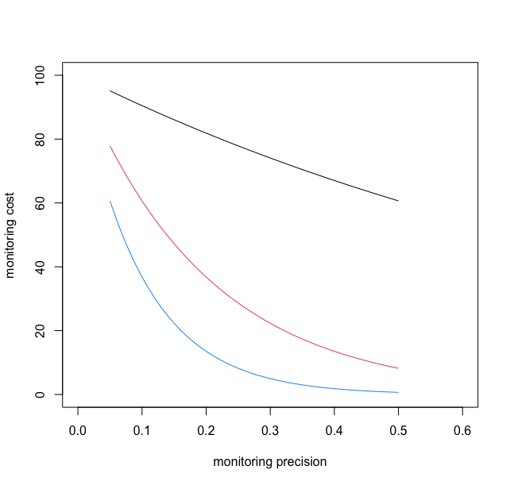
L247: Is this the same sigma parameter used before in the observation model? Or is this something else? In other words is it the "CV of biomass", as stated, which would have to be a temporal CV as there is one true value of Bt at time t, or is it the uncertainty associated with the observation of Bt. How would you in practice get a point estimate of sigma_t, if you only make one observation on Bt at time t?

Thank you for raising this point of confusion, we’ve updated it to clarify that it is the coefficient of variation of the biomass estimate, which in turn is a function of monitoring effort.
L258: Is this 'c' c_e?

Yes thank you. Revised.
L264: Ah I see my comment about line 247 seems to be answered here, but that could be cleared up earlier. Also here you are using CV instead of the sigma notation introduced earlier (and in ESM2 you use phi_t for the same quantity! Euclid and Pythagoras would be outraged).
We have revised the main text and supplement to clarify and apologize to Euclid, Pythagoras, and all living and dead mathematicians for the error of our ways.
L353: Again, the values of A only make sense relative to K (in this model with totally arbitrary parameters) so I would encourage expressing these values as proportions of K.
Please see above.
Fig 1: Is the black dashed line on the bottom edge of the gray region the value of A? Would be nice to indicate that.

Yes it’s A, we’ve revised.
Fig 3: This is a pretty figure but it is actually a bit difficult to distinguish the circles from triangles on the plot - maybe use bigger symbols that aren't filled in?

We’ve increased the symbol size and decreased the transparency
Fig 4: I am having trouble with this analysis because it seems to be pooling several distinct states into a binary metric. It would seem there are multiple possible outcomes of the model: a) population never dips into the danger zone, b) population enters danger zone and is rescued quickly, c) population enters danger zone and stays there a long time, d) population crosses the Allee threshold and goes extinct. So 'number of rescues' doesn't seem like a totally great metric because it combines cases (a),(c), and (d) in my list, pooling the best and worst case scenarios. It seems like it would be helpful for Fig 4 to screen out the (a) cases (no entry into danger zone) as white space, or alternatively use a metric like "proportion of time spent in danger zone" that might better reflect the situation.
This is a helpful suggestion, thank you. There is always some probability that the simulation dips into the danger zone (i.e. <0.8*Bmsy) for the combinations of monitoring precision and fishing effort considered for these 5000 simulation replicates, so there are no scenarios that follow (a) (i.e. there is no white space to fill in). We liked the idea of plotting proportion of time in the danger zone, but when we did we found that wasn’t particularly reflective of the results either because under low precision (high CV monitoring) the population crashes relatively frequently (see below). So we’ve retained the current figure but are open to any other suggestions if you have them.
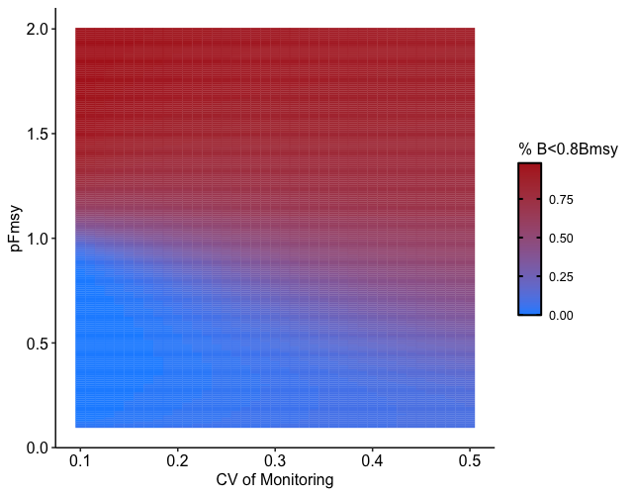
Fig 5: It looks like this figure isn't reference in the text? Seems important, though.

Thank you, we accidentally deleted some text in our revisions and have included the figure results and reference in the results.
L557: The reference for citation 16 seems to be wacky?

Revised
L271: But "collapse" and "tipping" are verbs and 'critical threshold' is a noun.

Revised

